Robin Hall Nursery Newsletter

Dear Parent(s)/Carer(s) of Robin Hall,

We hope that you enjoyed your festive break, and this newsletter will find you well and safe.

Welcome to Spring term and the new and exciting learning journey called People who help us.
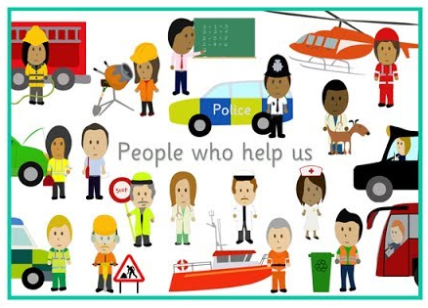
‘People who help us’ is a wide-ranging topic with plenty of opportunity for the children to make connections between themselves and the outside world. We are aiming at making the children more aware of the different jobs and roles people take on in their own homes, in school and in their local community.

This learning journey includes aspects of the local community, from friends to childminders and from shopkeepers to fire fighters. There are lots of people who help us in the community, and it is great for the children to learn about them. Some of these people help us in emergencies, like doctors and nurses, firefighters and police. Knowing more about them provides key life skills for children, for example, knowing how to dial the emergency services or who to ask if they get lost. Other people help us to stay safe, warm and healthy, like opticians, builders and refuse collectors.

Additionally, learning about ‘People who help us’ can also help allay fears for children who worry about going to visit dentists or have concerns about intruders or fire. We are also hoping that by talking about different roles and responsibilities in the community we will help to break down gender stereotypes and promote equal opportunities for everyone.

Preparing your home learning environment

This week we will be focusing on The Police Force and exploring how policemen and policewomen can help us.
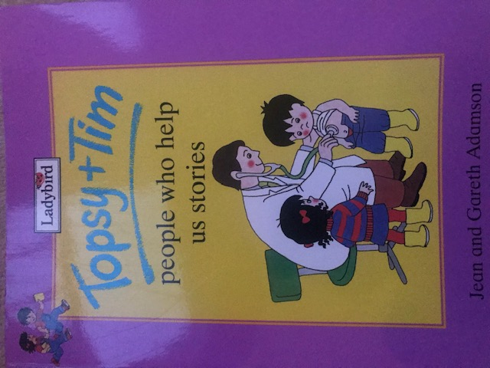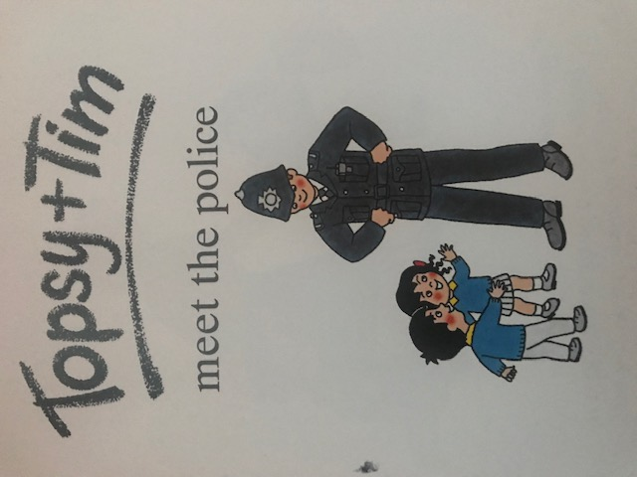
Listen, Talk and Role Play
Story read by Mrs Powrie
Listen to the recording of story of ‘Topsy and Tim meet the police’ by Jean and Gareth Adamson that we prepared for you.
Talk about the Police and act a play getting into the role of a police officer.
You can watch the story being read here.

Some facts to support you in talking to your child
-The police’s main job is to keep us safe.
-They try to stop crime and help to catch people who have committed crimes.
-They also control crowds of people in busy places.
-They sometimes direct the traffic or stop drivers from speeding.
-They wear uniforms and must carry special equipment to restrain people who have committed crimes, like handcuffs and leg straps.
-Some police drive cars with sirens and flashing lights on but others may ride on motorbikes, bicycles, boats, helicopters and even horses.

Did you know?
Dame Cressida Dick is the head of the Metropolitan Police in London. She is the first woman to take charge of the service, taking office in 2017.
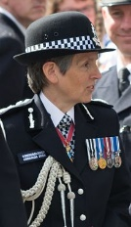
Here is an example:
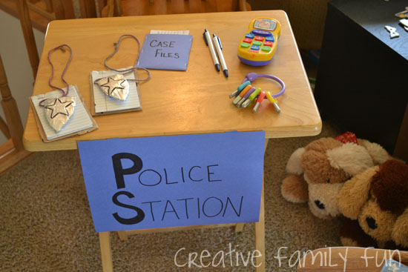

Create and Play
You can make a ‘Police Station’ den/corner in your home to act out and take on a role of a policeman or a policewoman.
Please help your child to make signs and draw pictures to decorate their ‘Police station’.

Design and Build
Make a Police Hat
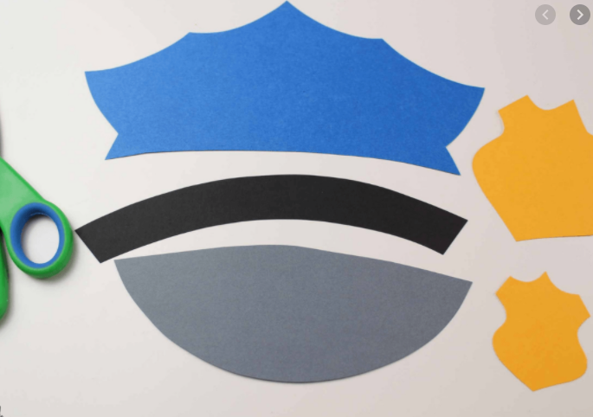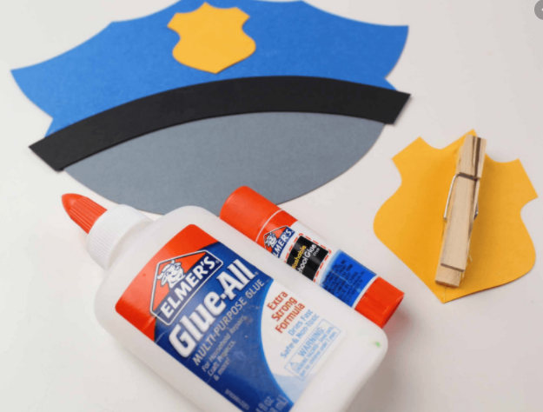
Design your own police hat that you can wear when you play in your own police station. Can you act out how the police officers help us?

Build a Police car
You can also build a police car out of out of recyclable boxes and bottles and decorate it with felt tip pens, paints and pencils that you have at home.
Have a think:
What parts will you need?
How many of each part?
What shapes are the parts?
Why does your police car need 4 wheels?
Why does it need windows?
What are the special markings on the police car?
Why do you think we need to see them?

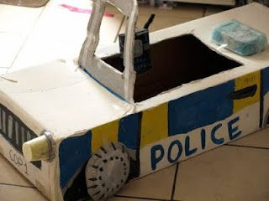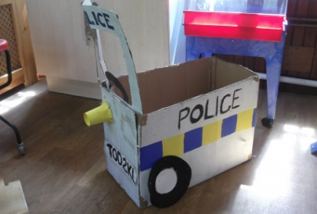

Investigate, count and mark make
Go on a walk outside. Who and what can you see?
Can you spot any ‘People who help us’? Who are they? Can you draw and label them? Can you see any Community Police officers?
Look for road signs: What shape are they? How many rectangle signs can you see? How many circle and triangle signs can you see? Can you draw them and write down the number of signs that you see?
What does it say on them? Can you try and read it with your grown up.
You can also go on a shape hunt around your home.

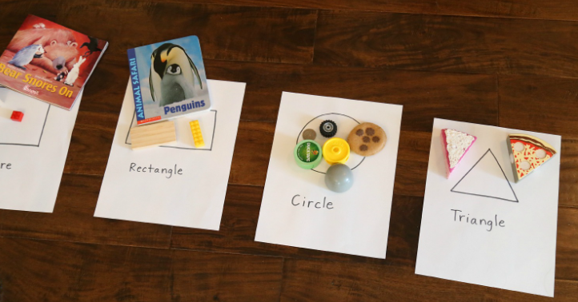

Look and Investigate
Look at your hands and fingers very closely. What can you see? Can you see bumps and grooves on the fingertip? What is a fingerprint?
The police use fingerprints to catch criminals.
If you would like to look at your own fingerprint use paint, flour or ink to make prints of your fingertips.
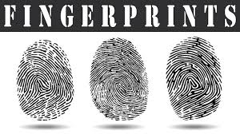

The focus story this week is
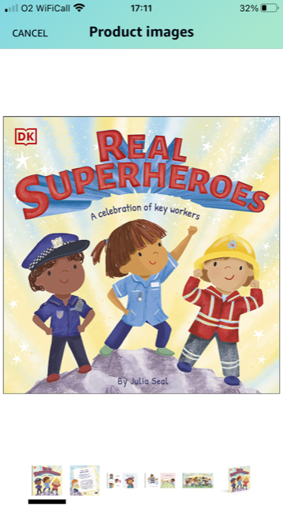
‘The Real SuperHeroes: A celebration of key workers’ by Julia Seal
Story read by Mrs Field
You can listen to the story here Part 1 and here Part 2
Communication and Language
Your focused task linked to the story is to talk about the favourite parts of the story with your adults. Which Key Worker Superhero do you like best and why? Can you draw a picture of your favourite ‘People who help us’ character in the story?

The Nursery rhyme of this week is: Miss Polly had a Dolly
Please join in and sing it with Mr Kapalamula. Can you do some actions too?
You can join in here.

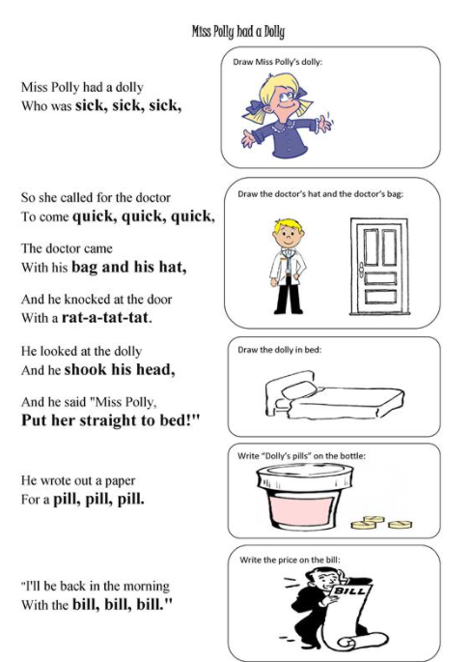

Dance and move about
Dance and move to Freeze dance music
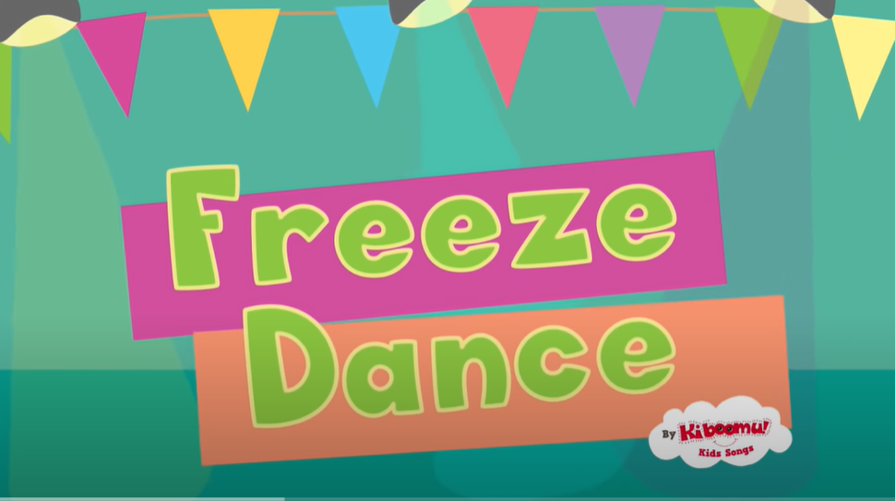
https://www.youtube.com/results?search_query=boogie+beebies

It is important that you read to your child daily, engage in regular conversations with them and sing songs and rhymes together. You can join CBeebies website to find many children’s favourites: https://www.bbc.co.uk/cbeebies/watch
If English is not your first language, please read and sing in your mother tongue as language universals are transferable and will benefit your child’s development greatly.
The Department for Education in England launched Hungry Little Minds in September 2019– a three-year campaign that aims to help parents understand that they have a big impact on their child’s learning and that reading, playing and chatting with them is a simple thing they can do to help them develop. Please visit the website for a great deal of activities and suggestions that you can engage in with your child to support them. https://hungrylittleminds.campaign.gov.uk/
Please keep us informed about your child’s learning at home. We would love to know how you get on with the activities suggested above or any fun learning activities of your own choice. Please send your photos and videos via Tapestry to us or send them to jpowrie@chat-edu.org and I will pass them on to the class teacher.
Keep safe and well.
Thank you for your support.
Justyna Powrie
EYFS Assistant Head Teacher

