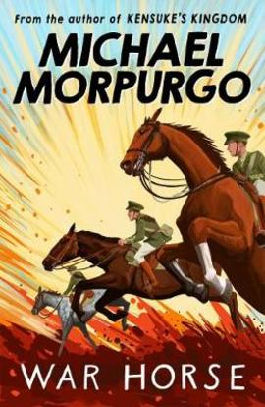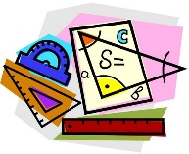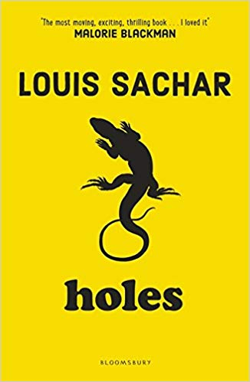

**Science**

In Year 5 we are learning:

Spring 1

**War Horse**

**Guided Reading**

* Focusing on consolidating the skills of addition, subtraction, multiplication and division and using these to solve multi-step problems.
* Recognising the importance of e-safety in order to safeguard children from potential dangers or unsuitable material.
* Studying forces – learning how gravity, friction and motion influence how objects move.
* Children to undertake dance lessons with a specialist dance teacher.
* Focusing on invasion games, especially rugby.

**P.E - Gymnastics**

* Studying the art of Frida Kahlo.
* Exploring Judaism – focusing on Jewish stories and celebrations.
* Studying rivers around the world – including how they are formed, the effects of pollution and producing a detailed report on a famous river.

**Maths**

**PSHE**

**R.E**

**Geography**

* Learning songs and writing rhymes using the programme Sing Up.
* Identifying rhythm and pitch in different songs.

**Music**

* Using an online platform called DB Primary to teach online safety to children.

**Computing**

* Studying William Shakespeare’s Macbeth and using this to write persuasive letters and develop descriptive pieces of writing.

**English**

**Art**