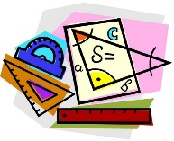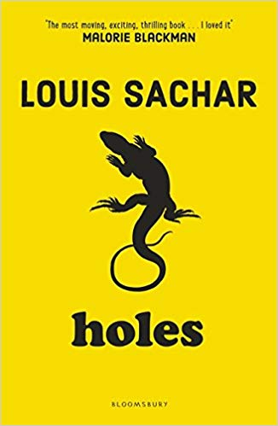

* Learning songs and writing rhymes using the programme Sing Up.
* Identifying rhythm and pitch in different songs.

Spring 1

In Year 3 we are learning:

* Focusing on adding and subtracting 3-digit numbers to another number including regrouping
* Adding and subtracting money.
* To find and use fractions of numbers such as 1/4 of 8 = 2 and 3/4 of 8 = 6.
* Passing and dribbling.
* To be able to use a range of skills to keep possession and make progress towards a goal, on my own and with others.
* To compare how things move on different surfaces.
* To see that some forces need contact between two objects, but magnetic forces can act at a distance.
* To be able to predict whether two magnets will attract or repel each other.
* Developing observational skills with plant art.
* To create depth in art work.
* Analysing where our food comes from.
* Comparing climate in the United Kingdom and other countries such as Italy and Vietnam.
* Understanding the significance of how food is made.
* To understand the importance of climate in other countries.
* Using an online platform called DB Primary to teach programming concepts such as sequences, computational thinking, movement and control.

**Computing**

* Writing a narrative and an explanation text.
* Analysing the language of a model text.
* Discussing why features exist within a text.
* Focusing inverted commas, verbs and adverbs.

**The Twits**

**Guided Reading**

* Recognising the importance of having dreams and goals.

**P.E**

* Exploring Gods in different religions.

**Maths**

**Science**

**PSHE**

**R.E**

**Geography**

**Music**

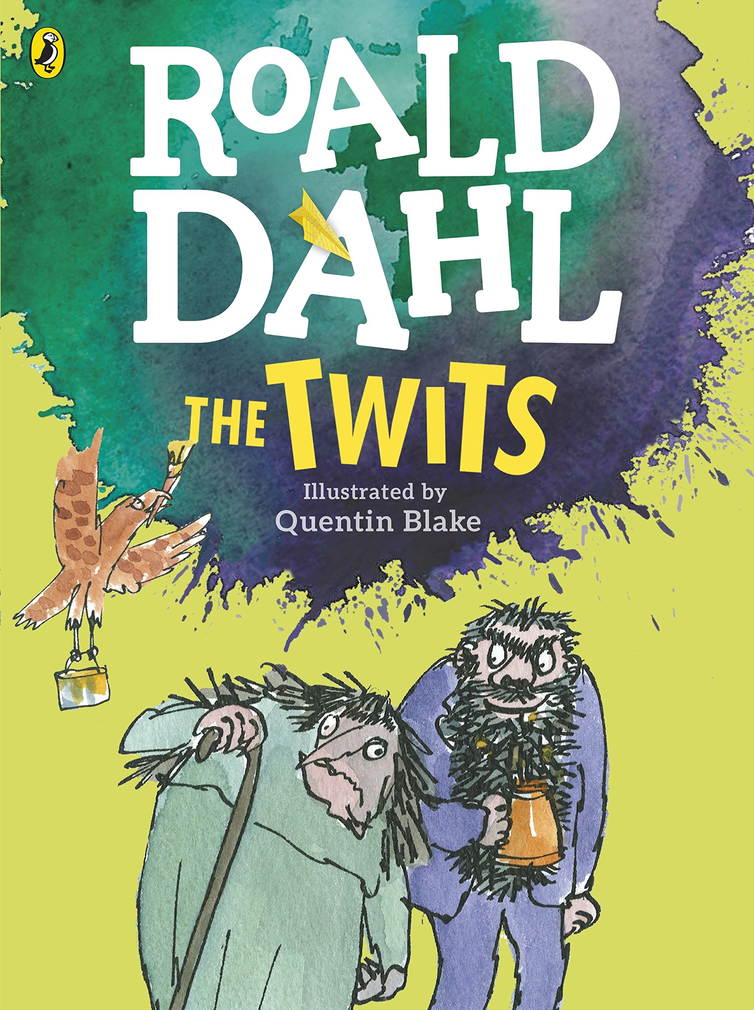

**English**

**Art**