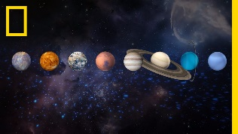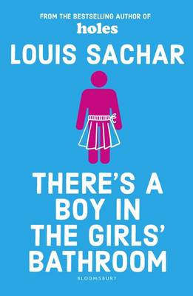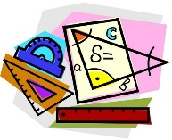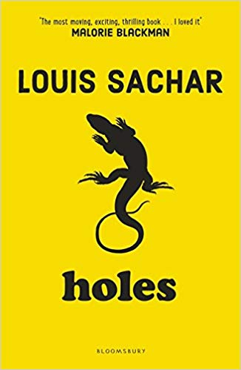

In Year 5 we are learning:

Autumn 2

**There’s a boy in the Girl’s Bathroom.**

**Guided Reading**

* Focusing on using rounding to check answers and make estimates.
* Further developing understanding of fractions, percentages and decimals.
* Recognising the importance of e-safety in order to safeguard children from potential dangers or unsuitable material.
* Studying Earth and Space – learning about the planets of the Solar System, orbits and how this creates seasons and day/night.
* Manipulating gymnastics equipment to develop balance and stability.
* Working with a partner to perform a gymnastics composition.

**P.E - Gymnastics**

* Designing and making Roman Art – including mosaics, shields and swords.
* Exploring Judaism – focusing on Jewish festivals such as Hanukkah
* Studying the Roman Empire especially focusing on the Romans in Britain and their influence.

**Maths**

**Science**

**PSHE**

**R.E**

**History**

* Learning songs and writing rhymes using the programme Sing Up.
* Identifying rhythm and pitch in different songs.

**Music**

* Using an online platform called DB Primary to teach online safety to children.

**Computing**

* Writing an information text based on Earth and Space
* Writing instructional texts.
* Writing persuasive letters.

**English**

**Design Technology**